**Switch Case Description:**

Switch case is used to execute multiple conditions.Corresponding to the condition we provide switch case gets executed and performs the action.For this multiple cases are provided in the form of a grid, and in it’s input variable case name has to be mentioned that has to be executed.

**Screenshots:**

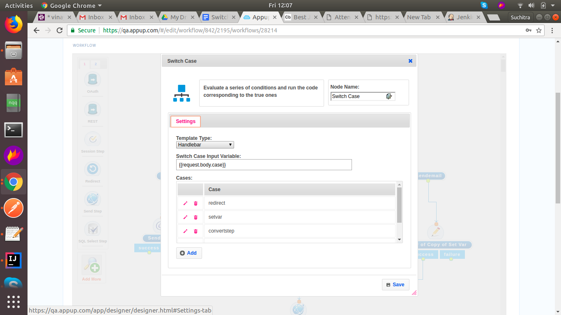

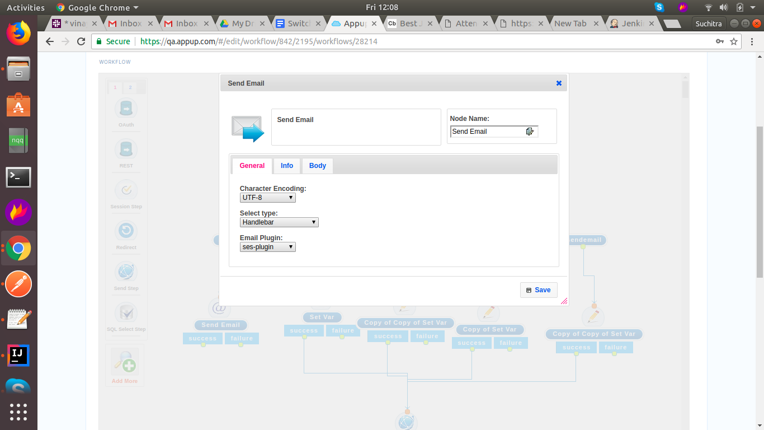

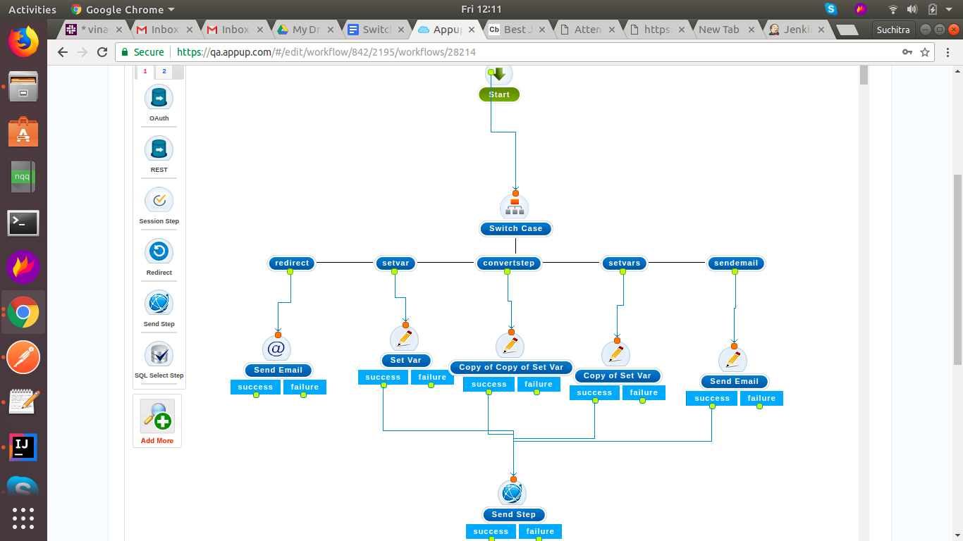

Postman Link:

<https://www.getpostman.com/collections/d6dcb340bc96f1d9c0a5>

Video Link: